
A10
Sreenidhi Institute of Science and Technology
(An Autonomous Institution)
Code No: 101ME23/111ME23
B. TECH. IV–Year I–Semester Examinations, Dec 2015/Jan 2016 (Supplementary)
PRINCIPLE OF FINITE ELEMENT METHOD (ME)

Time: 3 Hours Max. Marks: 70

Note: No additional answer sheets will be provided.

Part - A
Max.Marks:20

Answer all QUESTIONS. EACH QUESTION CARRIES 2 MARKS.
- What does discretization means in the finite element method?
- How do the stresses vary within the constant strain triangle element?
- State the conditions required for axi-symmetric problem formulation and mention any two examples
- Write the shape functions for a 3-D tetrahedral element
- Explain Galerkin method of finite element problem formulation
- Explain Lagrange method applied for finite element modeling of dynamic problems
- List five typical areas of engineering where the finite element method is applied
- Why it is required numerical integration for higher order finite element formulations
- Write the thermal load vector due to convection boundary condition in one dimensional steady state heat conduction problems
- Discuss the errors that arise in finite element method.

Part – B
Max.Marks:50
ANSWER ANY FIVE QUESTIONS. EACH QUESTION CARRIES 10 MARKS.
- For the bar assembly shown in Fig-1, determine the nodal displacements, the forces in each element, and the reaction at the support.
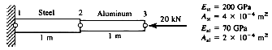Fig-1
- For the plane trusses shown in Fig-2, determine the horizontal and vertical displacements of node 1 and the stresses in each element. All elements have E =210 GPa and A=4x10⁻⁴ m².
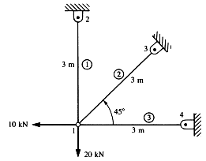 Fig-2
- For the beam shown in Fig-3, determine the nodal displacements and slopes, the forces in each element, and the reactions.
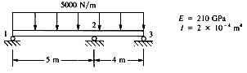Fig-3
- For the plane strain elements shown in Figu-4, the nodal displacements are given as u₁ = 0:005mm, v₁=0:002mm, u₂=0:0m, v₂=0:0mm, u₃=0:005mm and v₃= 0:0mm Determine the element stresses. Take E =70 GPa and ʏ=0:3, and use unit thickness for plane strain. All coordinates are in millimeters.
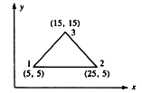Fig-4
- For the quadrilateral elements shown in Fig-5, evaluate the stiffness matrix. Take E = 210 GPa
andʏ =0:25. The global coordinates (in millimeters) are shown.
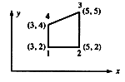 Fig-5
- For the composite wall shown in Fig-6, determine the interface temperatures.
What is the heat flux through the 8-cm portion? Use the finite element method. Use
three elements with the nodes shown.
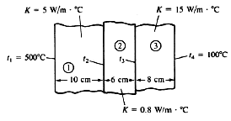 Fig-6
- For the beams shown in Fig-7, determine the natural frequencies using three elements. Use modulus of elasticity E, mass density ρ and cross-sectional area A, determine the first two natural frequencies and their mode shapes.
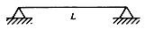 Fig-7.
- Explain
- Two-dimensional steady state heat conduction problems.
- Finite element formulation of Two-dimensional eight node quadrilateral element

-- 00 -- 00 –

